  

**ABASEACA MIHAI GABRIEL ANTON GINA BALABAN-DRAGOMIR**

**MARIANA-CARMELIA**

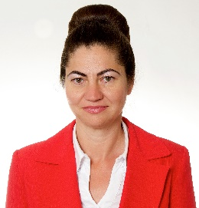 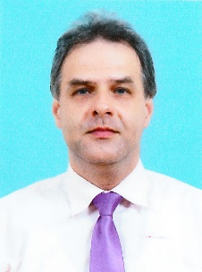 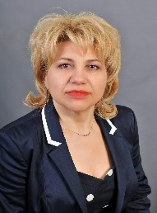

**BANICA CARMEN ELENA BOTEA VIOREL BROASCA VIRGINIA GIANINA**

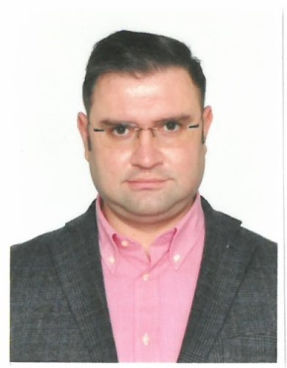 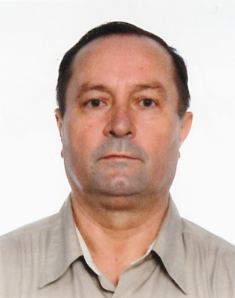 

**BUCALAU ALEXANDRU BURTEA FANEL CAPATINA MARIAN**

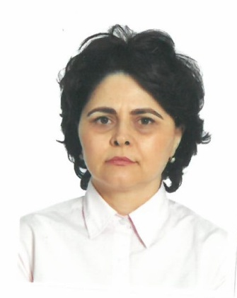 

**CHIVU MIRELA BASNO ALEXANDRU VLADUT CORTEZ VASILE**

 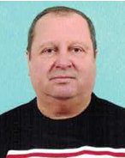 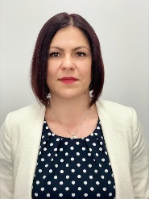

**DOROBANTU STAVAREL DUMITRU AUREL GERU LAURA OANA**

  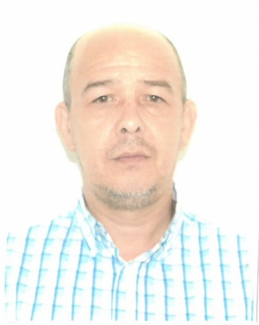

**GHIORGHIU MARIAN ICHIM ANDREI IONUT ISMAIL DURAN**

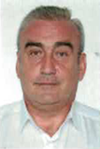  

**LUNGU DANUT NECOARA ANAMARIA NEGRU MARIUS-CATALIN**

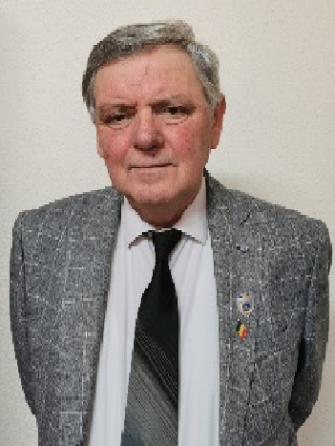  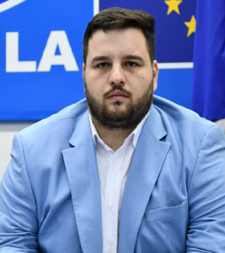

**ORZARU VASILE PRICOP CRISTIAN-FLORINEL SANDU COSMIN IULIAN**

 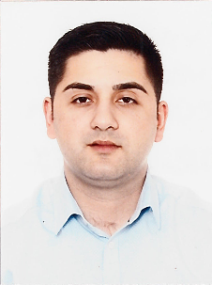 

**TURCOEANU VALENTINA VARGA VASILE-CONSTANTIN VILSAN DOREL**



**VLAD-PASCALE DANIELA-ANDREIA**